TNT Department of Innovation
  - Computer Science Department
Program Vision
Our computer science program embraces an "AI-First Learning" philosophy through our revolutionary S.P.A.R.K. framework (Set Goals, Prompt, Analyze Response, Refine, Know). Students collaborate with AI tools while developing critical thinking skills in a studio-based, visual-first environment.
Program Distinctives
- AI-Enhanced Learning: Students master collaboration with GitHub Copilot and other AI tools like Magic School
- Visual-First Development: Immediate visual feedback through graphics, animations, and web applications
- Professional Portfolio Building: Selected student work published at TechNoviceTools.com
- Industry-Standard Tools: Visual Studio Code, GitHub, and professional development practices
- Seminar-Style Collaboration: Students teach and learn from peers
Course Offerings
CS Foundation Studio: Visual Computing & Logic (Grades 9-12) Introduction to programming through Python3 and Turtle Graphics with Processing.py. Students create geometric art, interactive graphics, and algorithmic animations while mastering fundamental programming concepts. Prerequisites: Algebra 1 (A- or above) or departmental approval
AP Developer Studio: Java (Grades 10-12) Rigorous preparation for the AP Computer Science-A examination using Java programming. Covers complete College Board curriculum including object-oriented programming, data structures, and algorithm analysis. Offers comparative analysis with other languages such as Python3 and JavaScript. Time permitting, students will indulge with Processing graphics with Java. Prerequisites: CS Foundation Studio (preferred) or CS Innovations
CS Innovations Studio: Interactive Design (Grades 9-12) Modern web development using HTML5, CSS3, Bootstrap5, and JavaScript with p5.js. Students create professional-quality, responsive web applications and interactive designs. Prerequisites: Algebra 1 (A- or above) or departmental approval
CS Capstone Studio: Advanced Applications (Grades 11-12) Advanced students synthesize knowledge across multiple programming languages for sophisticated, real-world applications. Flexible specialization tracks include web applications, game development, cybersecurity, and emerging technologies. Prerequisites: (CS Foundation Studio OR AP Developer Studio) AND CS Innovations Studio
Honors Computer Science Intern (Grades 11-12, Application Required) Advanced students serve as peer mentors while pursuing independent projects. Emphasizes servant leadership, teaching skills, and advanced technical development. Prerequisites: Minimum of two CS Studio courses and application
Course Pathway
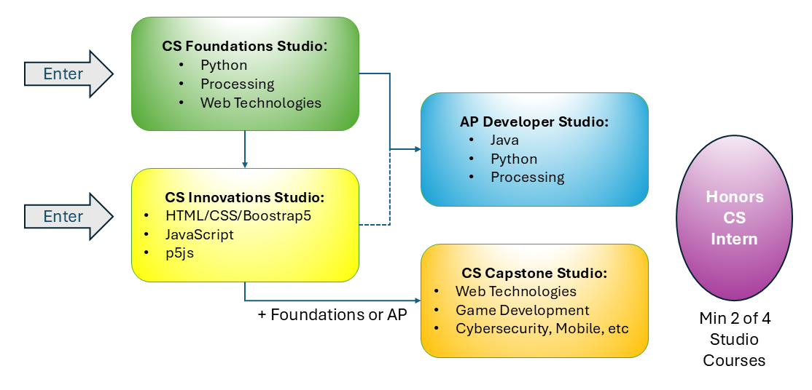
Students can enter at multiple points and follow flexible pathways based on their interests and preparation level.
Training Platforms
CodeHS • GitHub Copilot • Visual Studio Code • TechNoviceTools.com • Processing.org • Magic School • W3Schools
The S.P.A.R.K. Framework
Our pioneering methodology where students:
- Set Goals
- Prompt AI Agents
- Analyze Responses from AI
- Refine Solutions
- Know & Share with peers

